**Analysis Report**

**10% of the corpus**

|  |  |  |  |  |
| --- | --- | --- | --- | --- |
| Job | Mapper out records | Combiner out records | Map output bytes | Communications bytes |
| 1 | 804864240 | 16167331 | 16472993907 | 192294376 |
| 2 | 286994084 | 22502109 | 5293076518 | 329084346 |
| 3 | 10520885 | No combiner | 904675141 | 485373905 |

**100% of the corpus**

|  |  |  |  |  |
| --- | --- | --- | --- | --- |
| Job | Mapper out records | Combiner out records | Map output bytes | Communications bytes |
| 1 | 8224768431 | 160020205 | 171555131639 | 1928683093 |
| 2 | 2905871296 | 214028938 | 53510274112 | 3133862486 |
| 3 | 170864697 | No combiner | 14649227989 | 7685858410 |

**Evaluation Report**

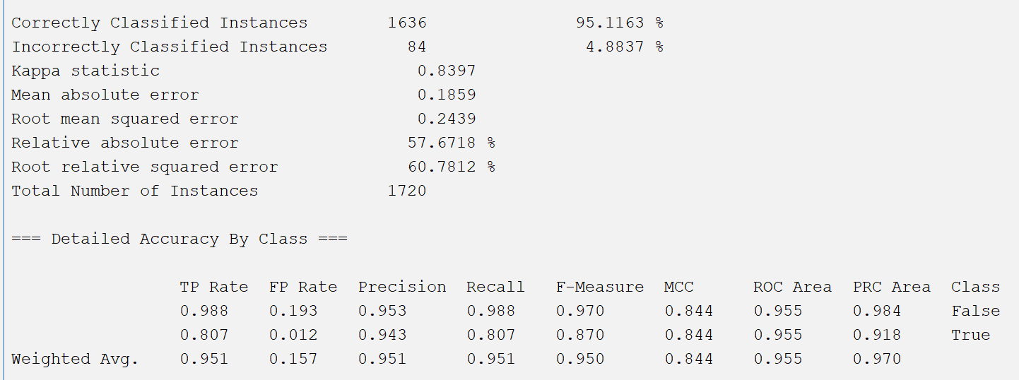**10% of the corpus**Precision -> 0.951  
Recall -> 0.951  
F1 -> 0.950

**100% of the corpus**Precision -> 0.951  
Recall -> 0.951  
F1 -> 0.950